Experiment 5: button control LED experiment
I / O is the input interface and output interface, lights experiments so far we design is applied to the Arduino I / O port output function, the experiment we try to use Arduino I / O port input function is the external device to read the output value, we with the touch of a button and a LED lights completed a combined input and output using the experiment, so that we can understand simple I / O. Pushbutton switch, we should be more understanding, belongs to the switch quantity (digital) element and press for closure (conduction) Completion of this experiment to
The components used are as follows:
Switch Key*1
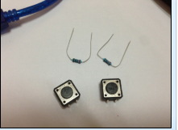

need hardware are as follows:
The red line M5 LED*1
220Ωresistence *1
10kΩresistence *1
Bread board *1
The bread board jump line *1 tie

We will be key to the digital interface of 7 red lights, received 11 digital interface（Arduino controller 0-13 digital I / O interface can be used to access buttons and lights, but try not to choose interfaces 0 and 1, 0 and 1 interfaces for reusable interface functions, in addition to I / O port function is serial port communication interface, download the program belongs to communication with the PC machine therefore should keep 0 and 1 interface suspended, so as to avoid the swap line trouble try not to use 0 and 1 interface），Connect the circuit according to the schematic diagram below.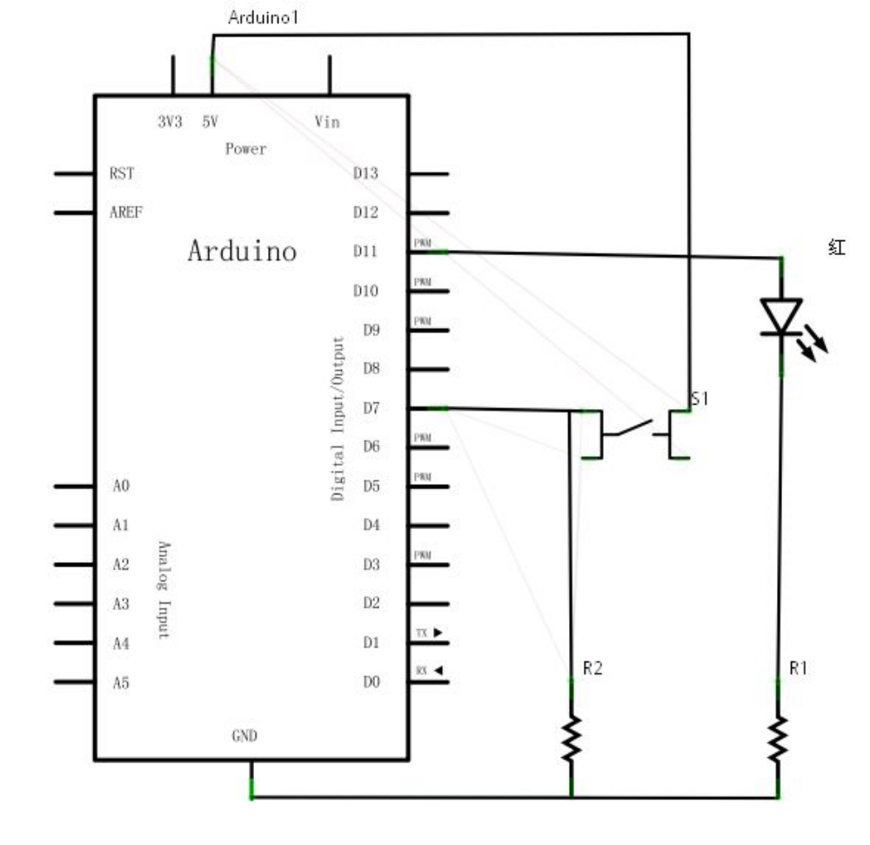
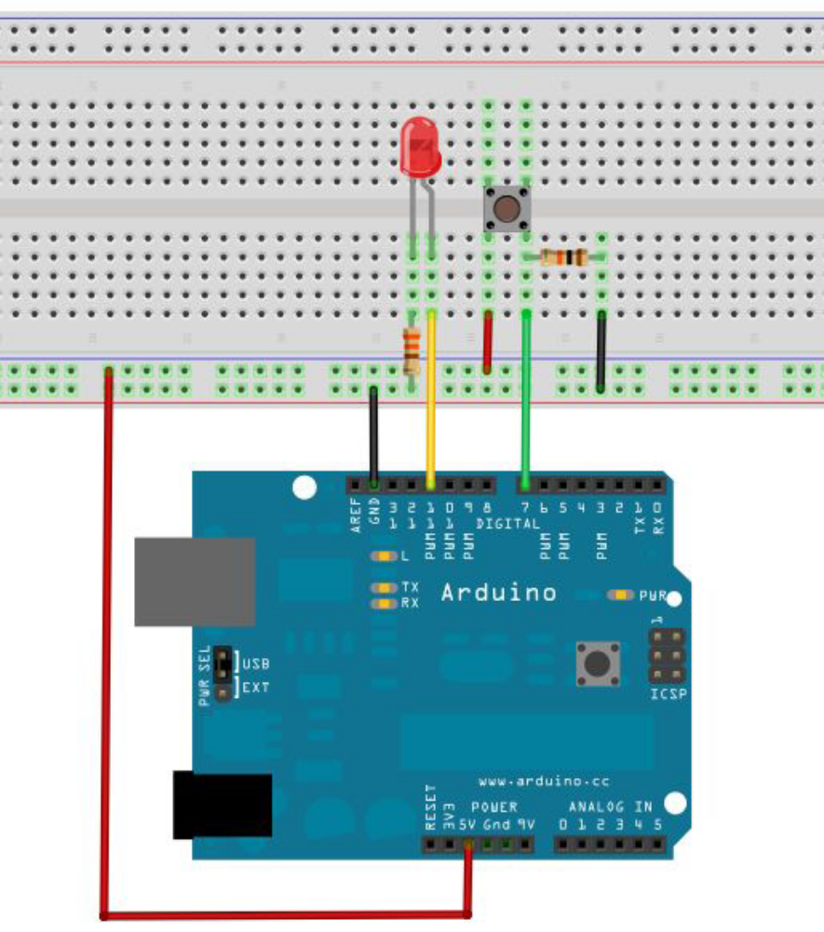
Physical connection diagram：
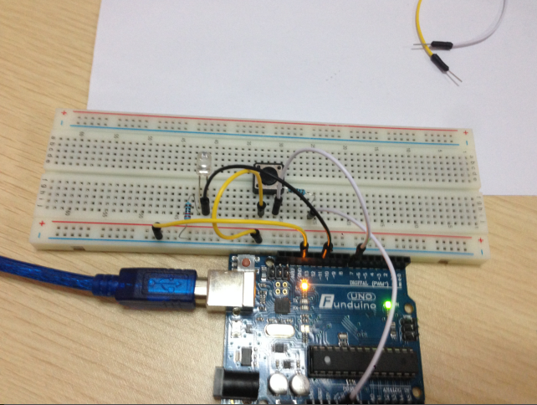
Following the start of program, we let the lights up when the button is pressed，According to the previous study I believe that this program is very easy to be able to write out, compared to the previous few experiments in this program to add a conditional judgment statement, where we use the if statement, Arduino program is based on the C language, so the C conditional judgment naturally applies to Arduino, like swich, while and so on.。Here according to personal preferences we are accustomed to using simple and easy to understand the if statement to do the demo routine.。
We analyze the circuit shows that when the button is pressed, the number 7 interface can be read for high level, then we make digital 11 high output level can make the lights lit, program we judge number 7 is a low level, low level the number 11 output port for low level light does not shine, ibid principle.
Reference source code：
int ledpin=11;//Define number 11 interface
int inpin=7;//Define number 7 interface
int val;//Defined variable val
void setup()
{
pinMode(ledpin,OUTPUT);//The definition of small interface for output interface
pinMode(inpin,INPUT);//Define button interface as input interface
}
void loop()
{
val=digitalRead(inpin);//Read digital 7 port level value assigned to val
if(val==LOW)//To detect whether the key pressed, press the button when the lights lit
{ digitalWrite(ledpin,LOW);}
else
{ digitalWrite(ledpin,HIGH);}
}
//////////////////////////////////////////////
Experimental results, and its phenomenon: when the button is pressed, LED light, the button is not pressed, the LED is not bright.

Downloading the program we the lights with the key experimental was completed, the principle is very simple, widely used in various circuits and electrical, in real life, we are not difficult to in a variety of equipment found, such as everyone's cell phone when the press any key backlight lamp will light up, this is a typical application of the. You can such as relay, 220V electric control.

